Trebuchet Evaluation Report

The challenge put forward to me and my team was that of the Trebuchet. I, Kush and Thinh were given the objective to design and assemble a trebuchet that was the most efficient and could throw the farthest. The frame of the trebuchet had to be made out of wood while the pouch was made out of string and J-cloths. The counter weight at the head of the trebuchet had to be 500 grams and the objective was to have a ball travel 3 metres however the goal was to throw as far as possible and as accurate as possible but the minimum benchmark was considered to be 3 metres. Finally there was one more very important factor there is a size restriction which is 30 cubic centimeters this was a major restriction for the trebuchet because the majority of the force came from the length of the arm. All of these things had to be considered for when we designed the trebuchet and for when we made changes because any change had to pass through strict restrictions.

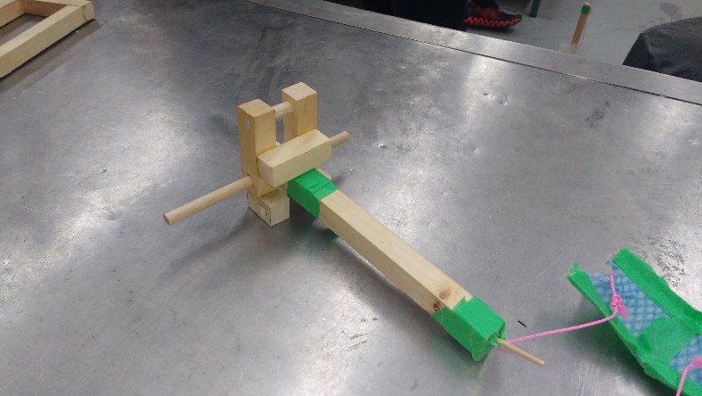The design of our trebuchet was an interesting one the design surrounded the idea that the arm length should be maximized for the longest throw. However the size restriction prevented us from doing so we came up with a solution (Figure 1.) the arm past the pivot point could bend back (Figure 2) allowing it to fit in the size restriction without losing arm length. However during testing we found a severe problem in our design that ruined our trebuchet. The arm was too long, this made it so since the end of the arm was so far away it created a huge loss in energy due to the counterweight not causing enough force through the height of the weight or the actual mass of the weight however we solved this problem by trimming the end of the trebuchet and that made the arm swing a lot faster and we got significantly better results.

Figure 2

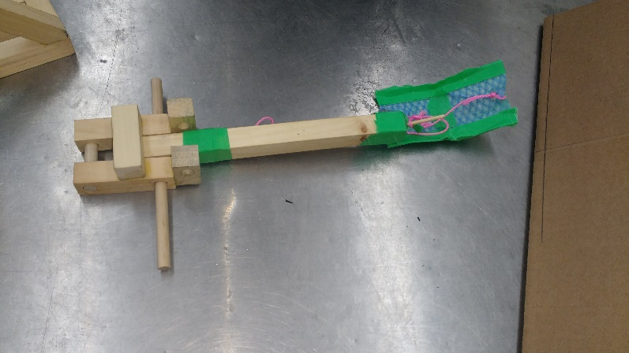Another problem we faced was the sling design it was one of the most pivotal design points in the trebuchet creation. Many people left it for last however it was extremely critical, we tested many designs from a spherical design to a just flat design however we settled on one design for its effectiveness we call it the hotdog design (Figure 3). The hotdog design prevent the ball from 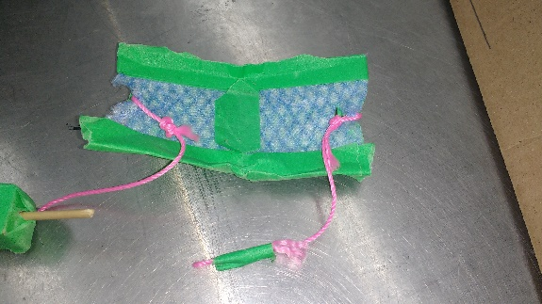falling out of the pouch because of its curved nature however it also does not hold the ball in too much like the spherical design did. Another thing we had to consider was how the pivot moved did the arm move independently of the axle and the axle was glued into the base or did the axle move with the arm and it rotated with the arm we eventually settled with the axle glued into the base this created only one location of friction for the trebuchet whereas the free moving axle would have two place of friction the two holes on the base.

Figure 1

Figure 3

Our design I feel was quite well done, it used the base model of a standard trebuchet however we made significant improvements to that design. I would say the strength of our design is in the consistency we managed to get the ball thrown over 3 metres consistently about 4 times in a row which was quite good for the competition we also got high in the standing in the competition about a few inches off of the record which I feel satisfied with. Our base was also well designed since many had the pivot point in the center of their base ours was in the front so it gave us that extra throwing length required to pass that three metre mark. However our weakness would be our pouch, though we tested multiple designs I still feel the pouch was the reason ours did not go the farthest through videos and testing you could see that the trebuchet did not launch the ball at its peak swing it was close however the pouch would often not work as well as intended.

I learned a lot from this project, I learned how trebuchets actually function and the key parts that make the trebuchet function. I also learned how to work with wood effectively with the chop saw and the drill press. I am satisfied with how our trebuchet function and how it worked however some changes could be made like as mentioned previously the pouch was the major problem in our design it prevent the trebuchet from acting with its maximum efficiency. I also would have tested the arm lengths, ours cut provided a faster speed however getting the arm length at the optimal length would have required a lot of time which we did not have. That is another thing we spent a lot of time planning and of course that time is important however I feel time was a major factor if we had spent less time doing intensive planning and more time testing different designs we could have had probably the best trebuchet since many people did not have their trebuchet one hundred percent finished in time and had to rush out a sloppy model. Overall this was a fun assignment that forced us to think about every aspect of design and have precise measurements and cuts which I have not experienced before.